**Database description:**

* **Domains:**

**positiveNumber**(from int) – check whether the number is positive;

**checkEmail**(from string) – check email;

**positiveDoubleNumber**(from double) – check whether a floating point number is positive and round it to 2 decimal placer;

**passwordCheck**(from string) – check whether a password has minimum eight characters, at least one letter, one number and one special character;

**placeClass**(from string) – class type from categories of wagons:

Categories of wagons:

**SW** – soft with 2-seater compartment;

**Luxe** – soft with 2-seater compartment with a bathroom;

**K** – compartment with 4-seater compartment;

**PL** – open-type passenger sleeping car (placed seat);

**Gen** – open carriage with seats (general);

**S** –carriage with seats;

**checkLogin**(from string) – login can’t start with a number or point, can contain digits, “_”, “.”

**Ticket:**

* Id : Int (PrKey)
* PlaceNumber: positiveNumber
* TypeOfPlace: placeClass
* ReceivingTime: Date
* TrainId: Int (ForeignKey)
* UserId: Int (ForeignKey)
* Price: positiveDoubleNumber
* DiscountInPercent: positiveDoubleNumber

**User**:

* Id: Int (PrKey)
* Login: checkLogin
* Password: passwordCheck
* IsAutorized: bool —
* Email: checkEmail
* moneyOnBill: positiveDoubleNumber

**Train**:

* Id: Int (PrKey)
* NumberOfPlace: positiveNumber
* Information: string
* TrainDescriptionId: int(ForeignKey)

**PlacesInTrain**:

* Id: Int (PrKey)
* TrainId: Int (ForeignKey)
* TypeOfPlace:placeClass
* NumberOfTickets: positiveNumber

**TrainDescription**:

* Id: Int (PrKey)
* DateOfJourney: Date
* StartPoint: string
* StartTime: Time
* FinishPoint: string
* FinishTime: Time

**UML-diagram:**

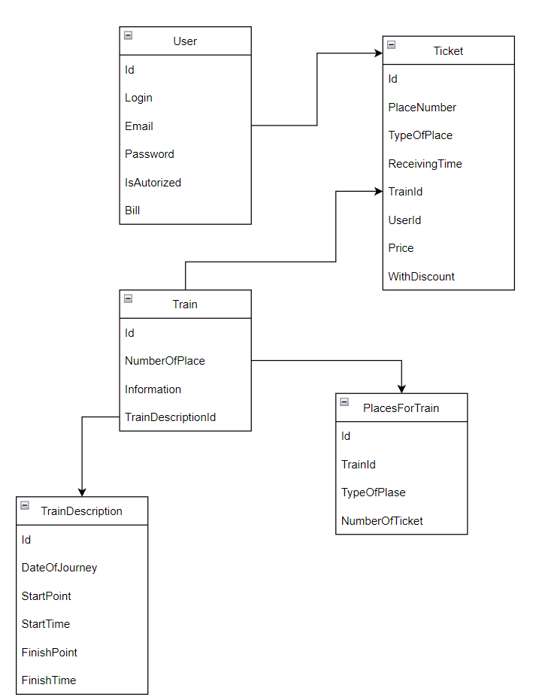

**ER-diagram:**

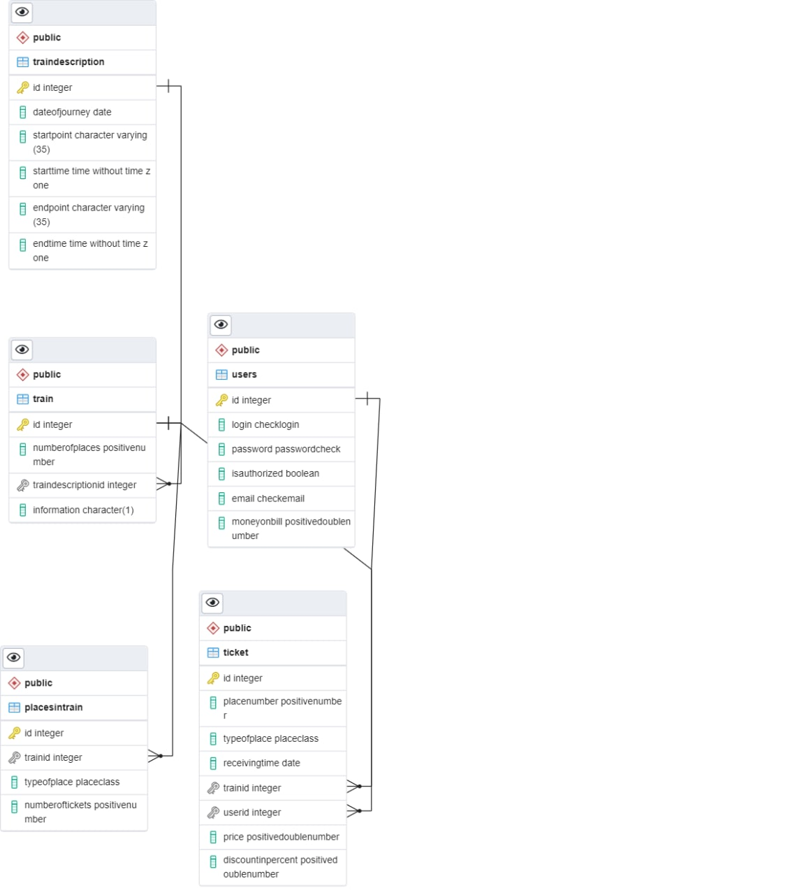

**Код БД:**

**CREATE DOMAIN positive_number AS INTEGER**

**CHECK(VALUE>=0);**

**CREATE DOMAIN check_email AS TEXT**

**CHECK(VALUE ~ '^\w+([\.-]?\w+)*@\w+([\.-]?\w+)*(\.\w{2,3})+$');**

**CREATE DOMAIN place_class AS VARCHAR(4)**

**CHECK(UPPER(VALUE) IN ('SW', 'LUXE', 'K','PL','GEN','S'));**

**CREATE DOMAIN password_check AS TEXT**

**CHECK(VALUE ~ '^(?=.*[A-Za-z])(?=.*\d)(?=.*[\_\.])[A-Za-z\d\_\.]{8,}$');**

**CREATE DOMAIN check_login AS TEXT**

**CHECK(VALUE~'^[A-Za-z\_][A-Za-z\d\_\.]{0,19}$');**

**CREATE DOMAIN positive_double_number AS NUMERIC(10,2)**

**CHECK(VALUE>=0);**

**CREATE TABLE users(**

**id serial NOT NULL PRIMARY KEY,**

**login check_login unique NOT NULL,**

**password_ password_check NOT NULL,**

**isAuthorized bool NOT NULL,**

**email check_email unique NOT NULL,**

**moneyOnBill positive_double_number NOT NULL**

**);**

**CREATE TABLE train_description(**

**id serial NOT NULL PRIMARY KEY,**

**dateOfJourney date NOT NULL,**

**startPoint VARCHAR(35) NOT NULL,**

**startTime time NOT NULL,**

**endPoint VARCHAR(35) NOT NULL,**

**endTime time NOT NULL**

**);**

**CREATE TABLE train(**

**id serial NOT NULL PRIMARY KEY,**

**numberOfPlaces positive_number NOT NULL,**

**trainDescriptionId serial NOT NULL,**

**information text NOT NULL,**

**FOREIGN KEY (trainDescriptionId) REFERENCES train_Description(id) ON DELETE CASCADE**

**);**

**CREATE TABLE places_in_train(**

**id serial NOT NULL PRIMARY KEY,**

**trainId serial NOT NULL,**

**typeOfPlace place_class NOT NULL,**

**numberOfTickets positive_number NOT NULL,**

**FOREIGN KEY (trainId) REFERENCES train(id) ON DELETE CASCADE**

**);**

**CREATE TABLE ticket(**

**id serial NOT NULL PRIMARY KEY,**

**placeNumber positive_number NOT NULL,**

**typeOfPlace place_class NOT NULL,**

**receivingTime date NOT NULL,**

**trainId serial NOT NULL,**

**userId serial NOT NULL,**

**price positive_double_number NOT NULL,**

**DiscountInPercent positive_double_number,**

**FOREIGN KEY (trainId) REFERENCES train(id) ON DELETE CASCADE,**

**FOREIGN KEY (userId) REFERENCES users(id) ON DELETE CASCADE**

**);**

Також ми підготували кілька інсертів для декількох таблиць, проте не встигли навіть створити саму БД:

**INSERT INTO users VALUES**

**(1,'Aoe_1','Ta2rr4_9Ii', True,'testmail@gmail.com',1233.55),**

**(2,'Dyy_5','ffSS67_4', True,'emdy33@mail.com',2363.13),**

**(3, 'Hmnis', 'QWer.ty1234', True, 'qwer098@tyy.ua',123.45),**

**(4, 'Bob4', 'StAr_576', True, 'drsae@new.com',445.66);**

**INSERT INTO train_description VALUES**

**(1,'2022-01-08', 'A','13:00', 'B', '14:00'),**

**(2,'2022-01-08', 'B', '14:10','C','15:25');**

**INSERT INTO train VALUES**

**(1,145, 3, 'Fact. Train travel was made popular by Abraham Lincoln`s assassination.');**